Entropy weight calculation software Installation instructions

#### System support

The following table shows the operating systems that support the Entropy weight calculation software installation. The software with a green background can be directly installed and used, while the software with a white background needs to be installed first .NET Framework (version 4.7.2 or above) is required to install and use this software. Windows XP system supports up to .net4.0, so this software cannot be installed and used; For Windows 7 or Windows Server 2008 R2 systems .NET Framework requires Service Pack 1 (SP1).

|  |  |
| --- | --- |
| **Windows version** | **Built in .NET Formwork version** |
| Windows 11 | .NET Framework 4.8 |
| Windows 10 22H2 | .NET Framework 4.8 |
| Windows 10 21H2 | .NET Framework 4.8 |
| Windows 10 21H1 | .NET Framework 4.8 |
| Windows 10 20H2 | .NET Framework 4.8 |
| Windows 10 2004 | .NET Framework 4.8 |
| Windows 10 1909 | .NET Framework 4.8 |
| Windows 10 1903 | .NET Framework 4.8 |
| Windows 10 1809 | .NET Framework 4.7.2 |
| Windows 10 1803 | .NET Framework 4.7.2 |
| Windows 10 1709 | .NET Framework 4.7.1 |
| Windows 10 1703 | .NET Framework 4.7 |
| Windows 10 1607 | .NET Framework 4.6.2 |
| Windows 10 1511 | .NET Framework 4.6.1 |
| Windows 10 1507 | .NET Framework 4.6 |
| Windows 8 SP1 | .NET Framework 4.5.1 |
| Windows 8 | .NET Framework 4.5 |
| Windows 7 SP1 | .NET Framework 3.5.1 |
| Windows Server 2022 | .NET Framework 4.8 |
| Windows Server 2019 | .NET Framework 4.7.2 |
| Windows Server 2016 1809 | .NET Framework 4.7.2 |
| Windows Server 2016 1803 | .NET Framework 4.7.2 |
| Windows Server 2016 1709 | .NET Framework 4.7.1 |
| Windows Server 2016 | .NET Framework 4.6.2 |
| Windows Server 2012 R2 | .NET Framework 4.5.1 |
| Windows Server 2012 | .NET Framework 4.5 |
| Windows Server 2008 R2 SP1 | .NET Framework 3.0 |

#### Installation steps

If the following prompt appears, please download and install it first .NET Framework version 4.7.2 or above:

(Please refer to [Extension - Download .NET Framework 4.7.2 Installation Package])

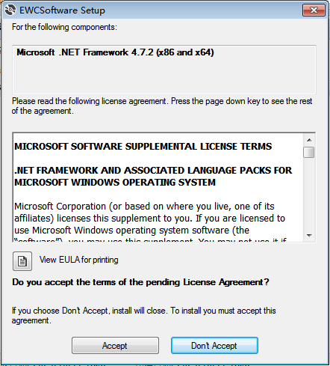

1. Double click EWCSoftware.msi to start installation:



1. Click Next:

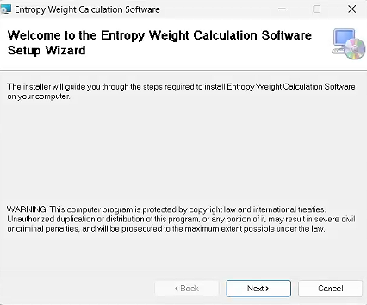

1. Click Next:

(Tip: The default installation path is C:\Program Files (x86)\EWCSoftware\, and users can customize and choose to change it)

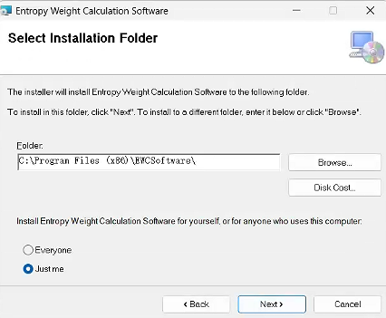

1. Click Next:

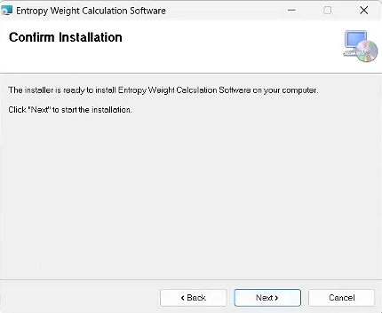

1. Installation completed!click Close to close the installation interface.

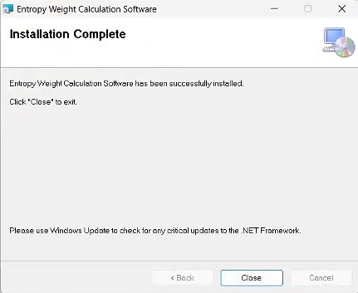

1. How to uninstall this software: Start menu->EWCSoftware->uninstall EWCSoftware.

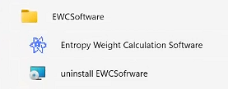

#### Extension - Download .NET Framework 4.7.2 Installation Package

##### Installation method 1:

Open the Control Panel->Programs->Programs and Features->Turn Windows features on or off ->Check the box Install .NET Framework 4.8 Advanced Services.

##### Installation method 2:

.NET Framework 4.7.2 offline installer package download address：

<https://support.microsoft.com/en-us/topic/microsoft-net-framework-4-7-2-offline-installer-for-windows-05a72734-2127-a15d-50cf-daf56d5faec2>

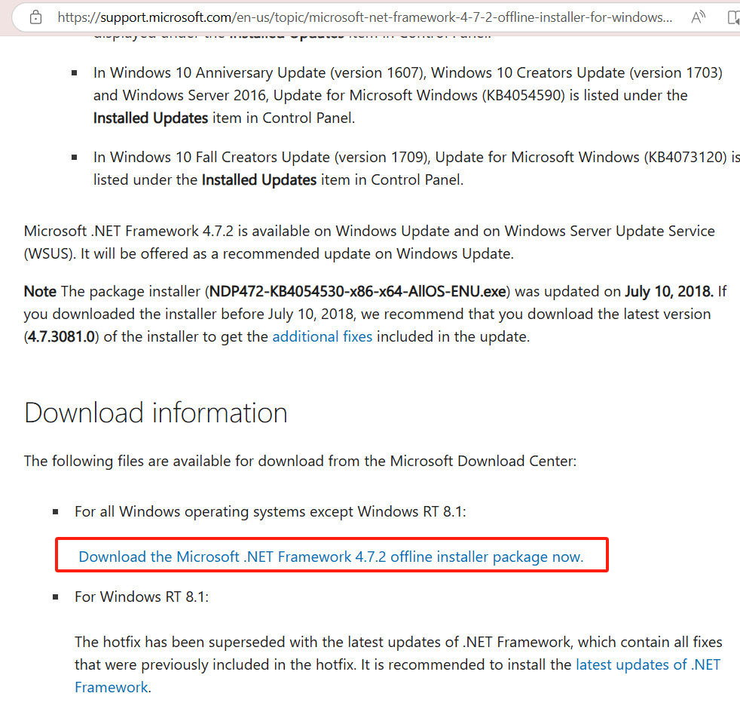

1. Double click the downloaded file to start installation:

(Tip: Please store the installation files in a fully English path, otherwise installation may not be possible)



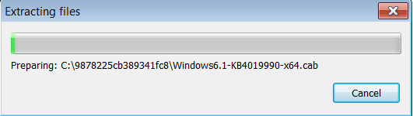

1. Check the box to accept the license terms:

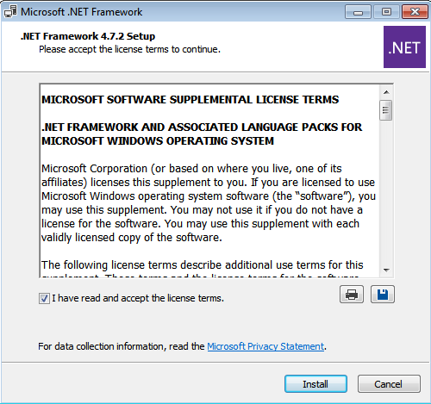

1. Waiting for installation:

(If the installation Did Not Succeed,Prompt 'A Certificate chain processed, but terminated in root certificate which is not trusted by the trust provider.',See [Expansion Installation Certificate] for details;Prompt "The timestamp signature and/or certificate could not be verified or is malformed",Please refer to [Extension - Install Patch] for details)

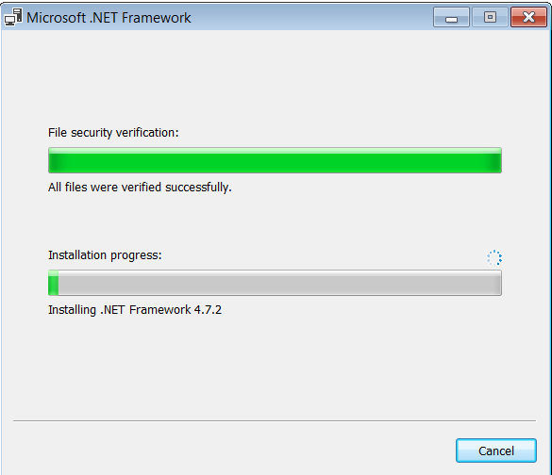

1. Installation Is Complete:

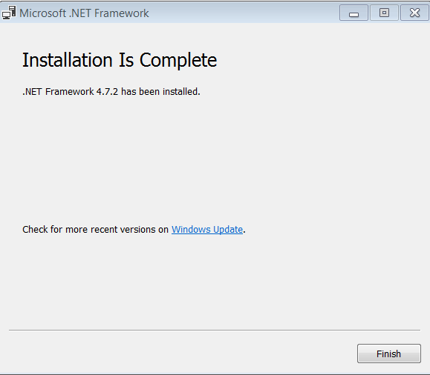

#### Expansion Installation Certificate

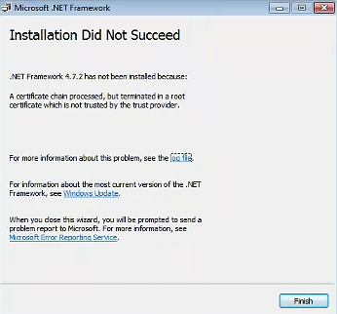

1. Download root certificate:[MicrosoftRootCertificateAuthority2011.cer](http://download.microsoft.com/download/2/4/8/248D8A62-FCCD-475C-85E7-6ED59520FC0F/MicrosoftRootCertificateAuthority2011.cer)

<http://download.microsoft.com/download/2/4/8/248D8A62-FCCD-475C-85E7-6ED59520FC0F/MicrosoftRootCertificateAuthority2011.cer>



1. Open Win+R and run, enter MMC, click OK

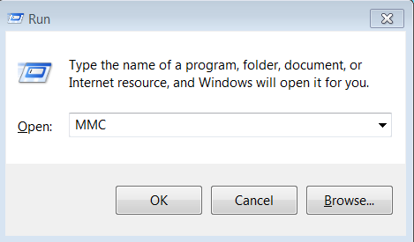

1. File->Add/Remove Snap-in...

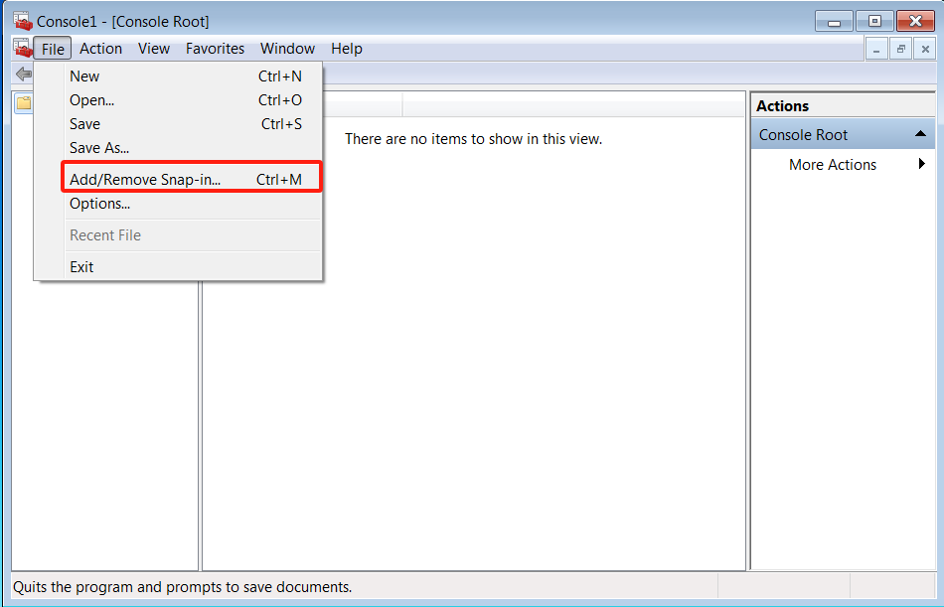

1. Select the Certificates->Click Add

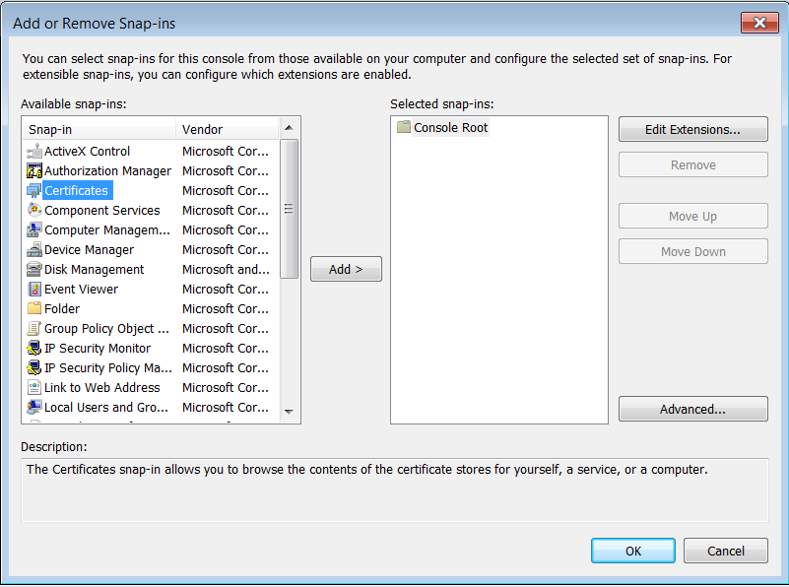

1. Select Computer account->Click Next-> Click Finish->Click OK

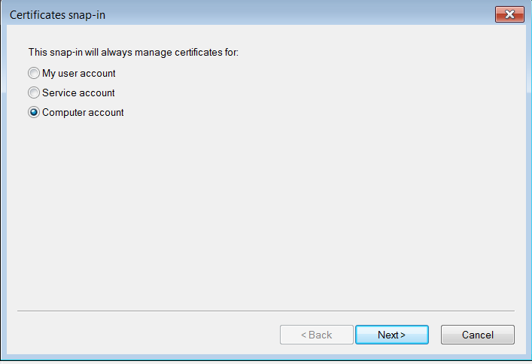

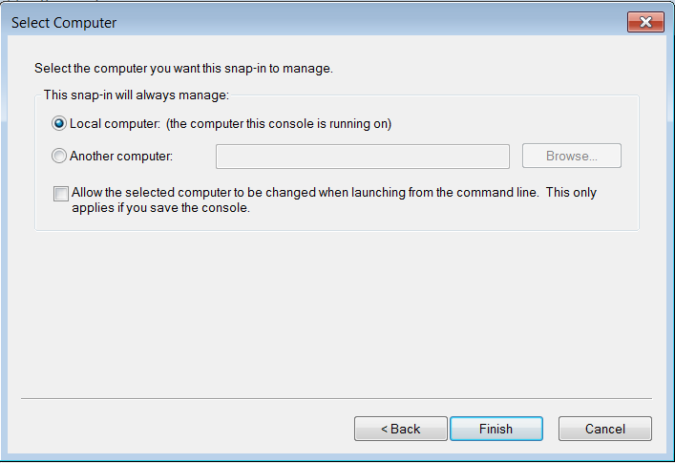

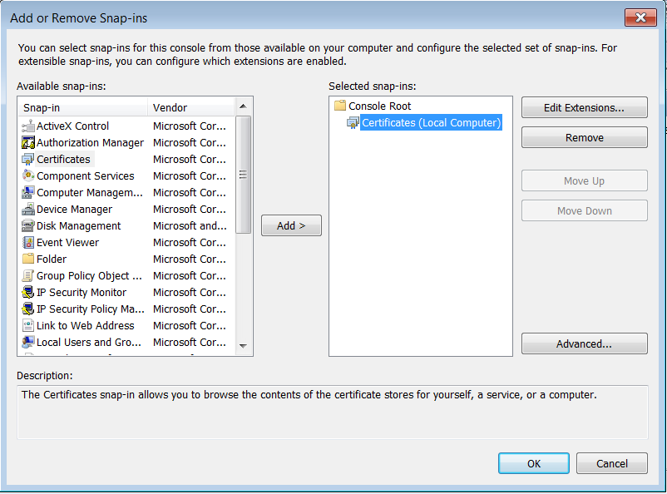

1. Expand Trusted Root Certification Authorities ->right-click Certificates->Select All Tasks ->Click Import

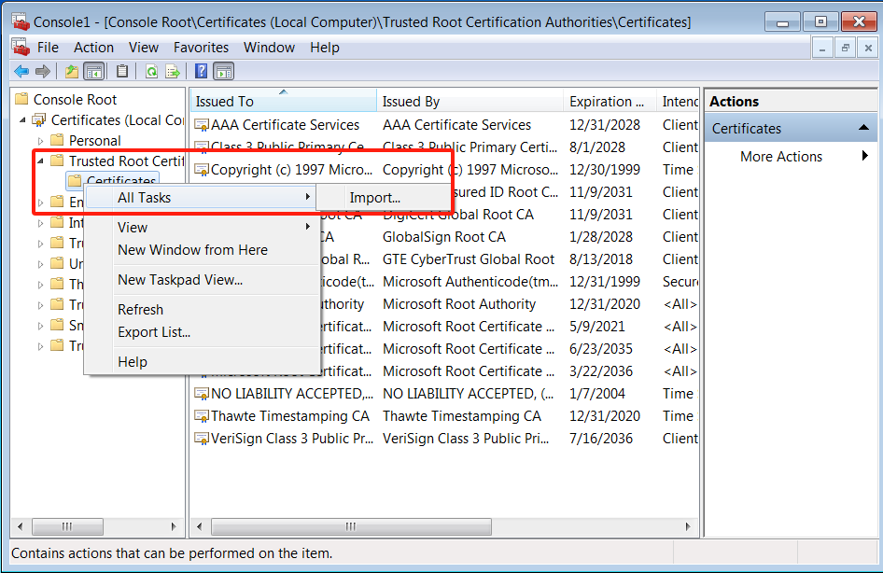

1. Click Next:

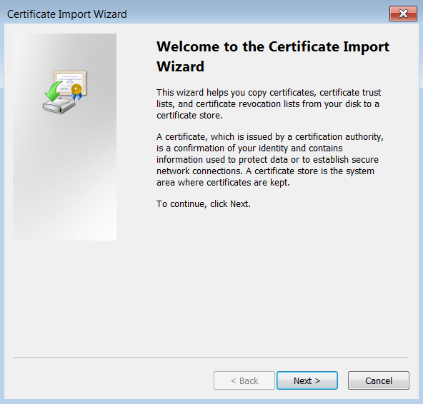

1. Select the certificate that was just downloaded and import it->Click Next:

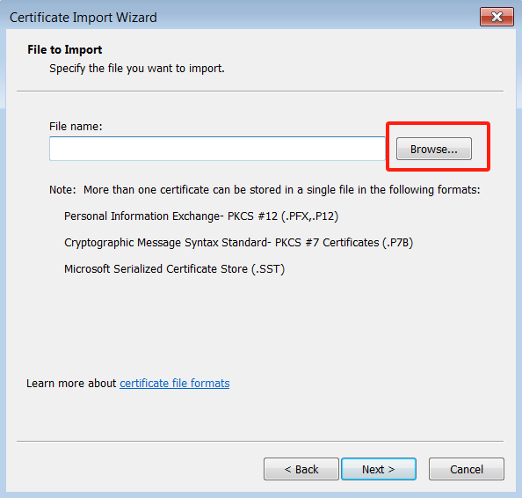

1. Click Next:

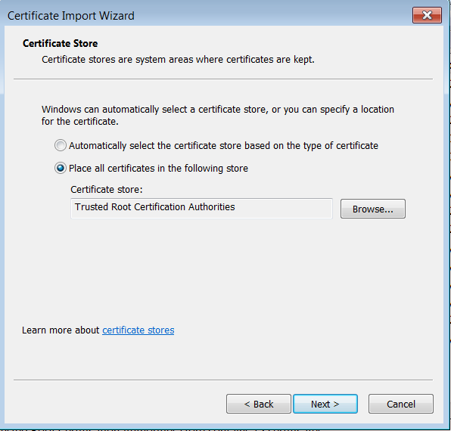

1. Click Finish:

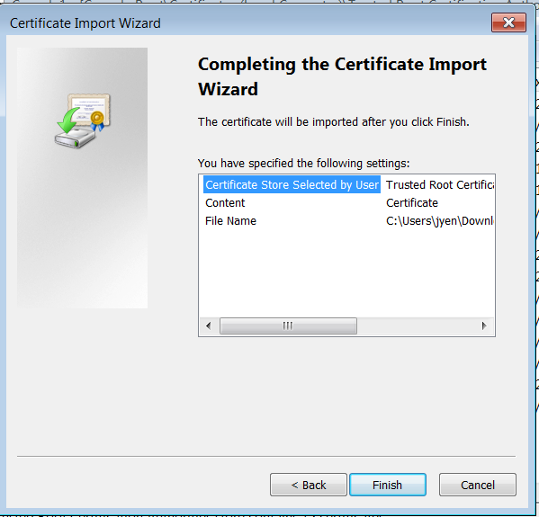

1. The certificate import was successful.

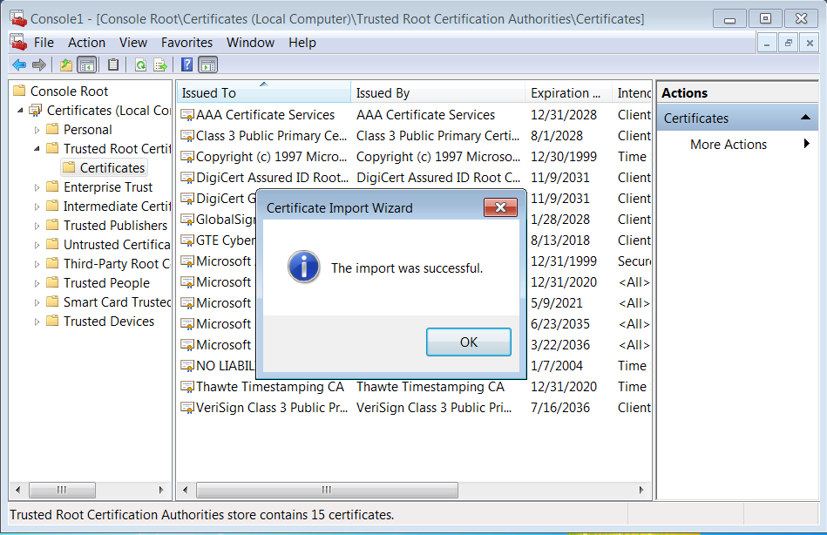。

#### Extension - Install Patch

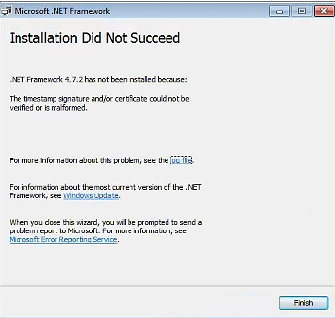

1. Install independent security update KB4474419:This update introduces SHA-2 code signing support,Can solve the installation Certificate issues in .NET Framework.The patch download address is:

<https://www.catalog.update.microsoft.com/search.aspx?q=kb4474419>

Download the corresponding patch package based on the system type of the computer:

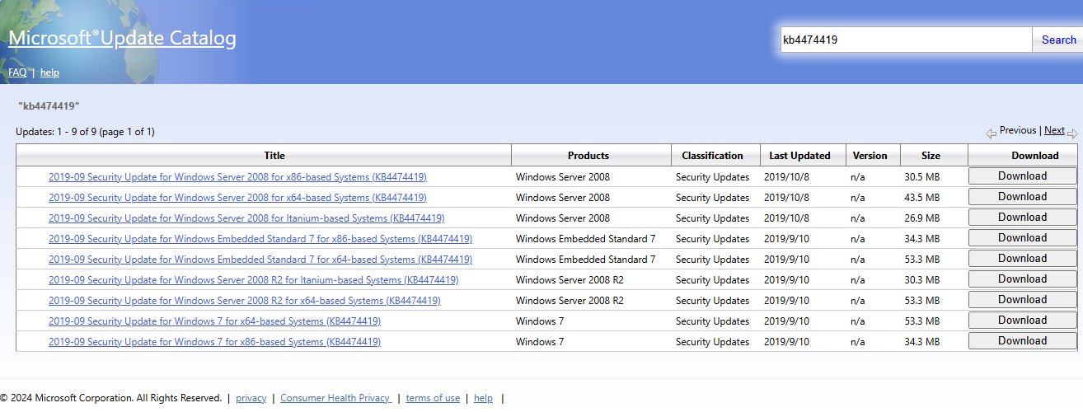

1. Double click the downloaded patch file to start installation->Click OK



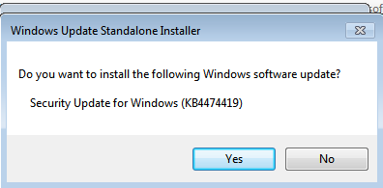

1. Waiting for installation and updates

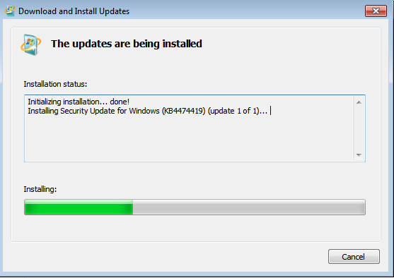

1. Installation complete->Restart your compute

